**b. Identify major markets for the district “Agra” and plot price patterns for each of**

**them. What patterns do you identify?**

**Ans.** = Achnera, Fatehpur Sikri and Agra are some of the major markets in Agra District.

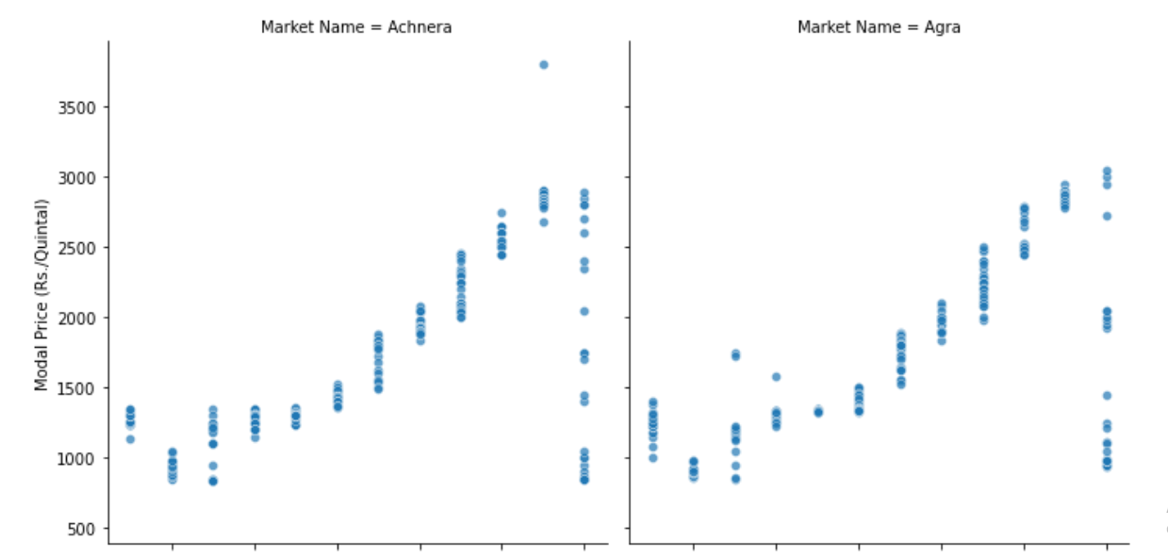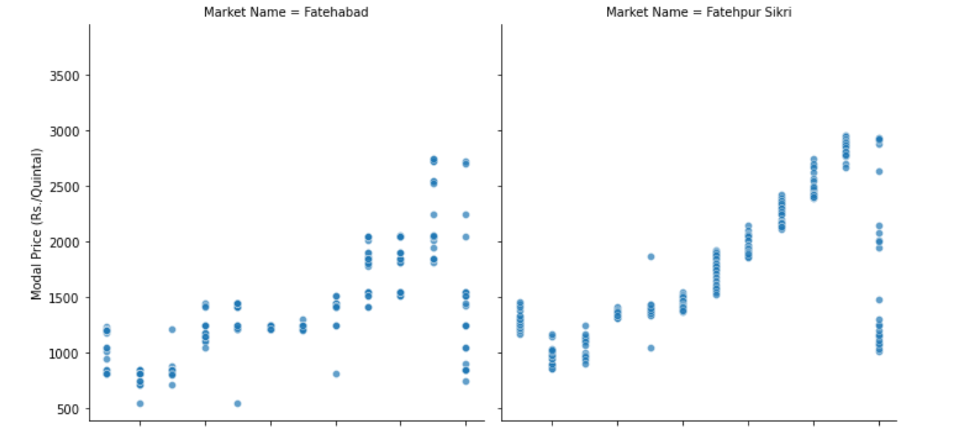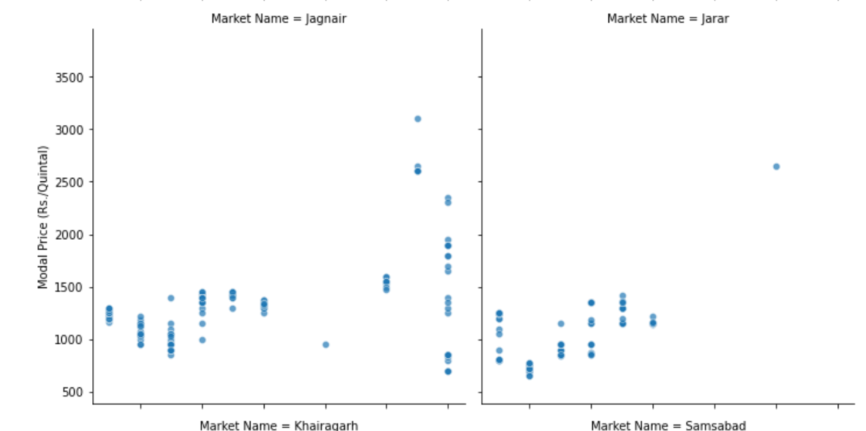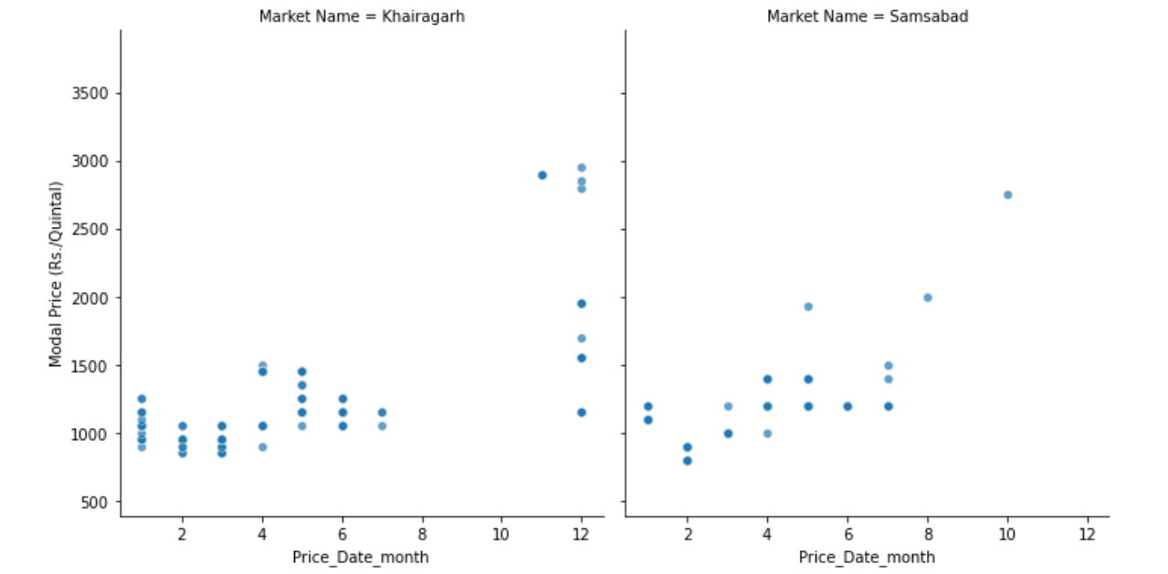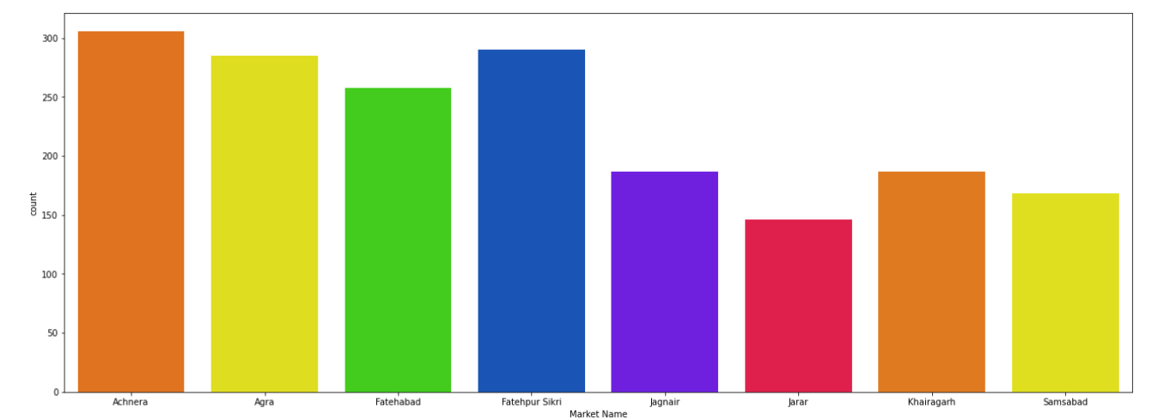

We can easily notice from the plots given above the Achnera market have maximum number of entries and there is posted throughout the year. Similarly with Fatehpur Sikri and Agra markets are other important market in Agra District. Fatehabad is 4th important market in agra for Potato crop.

**c. Comment on how you can leverage machine learning to predict prices for a given**

**market in Agra for the crop “Potato”.**

**i. What are the data pre-processing / cleaning techniques you would apply?**

**Ans.** The dataset contains 10 columns and 1826 rows. There were no Null values found in the dataset. I used “Price Date” column to extract data like Month, Day, Day name, and Quarter. So we can easily identify patterns like how frequently price change with respect to time.

I have used Label encoder to transform data and One-hot-encoder to convert categorical data into numerical data type which includes 'District Name', 'Market Name', 'Commodity', 'Variety', 'Grade', 'Price_Date_day_week' columns.

**ii. What are the features you would use to create the model?**

**Ans.** Market Name, Variety, Grade, Price_Date_month, Price_Date_quater are some of the important features to create a model.

**iii. How would you frame this problem as a machine learning problem? What**

**would be the target variable?**

**Ans.**  We can frame this machine learning problem as :

1. to predict future prices of data.

2. we can check the which market is likely to pay higher price for a particular type of crop to make profit.

Target variable will be Price of crop.

**iv. Which algorithm would you use for price prediction?**

**Ans.** Here I used random forest regression algorithm fr predicting price. Decision tree regressor and gradient boosting regressor are other algorithms that can be used.

**v. What would be the loss function you would use?**

**Ans.** I would use Mean Squared Error as my Loss fuction.

**vi. Any other comments you want to add?**

**Ans.** Price prediction might depend up on the other factors like: climate condition and demand & supply ratio.